Business Model You template

Use this Business Model You template to get practical insights regarding (complex) career decisions by focusing on your talents, goals, needs, desires and your environment. The text fields in this template are editable. You can also clear the fields and print this template to create hand-outs of this Business Model You template.

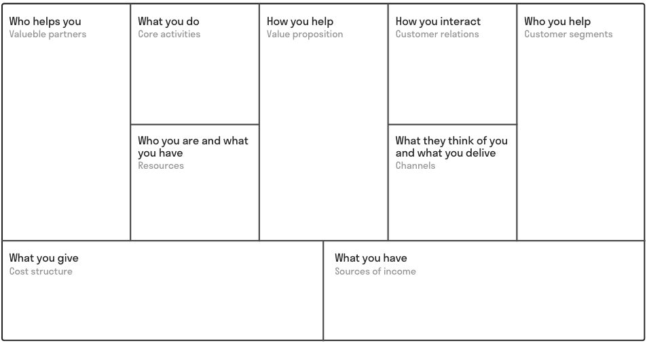
- For more information about Business Model You, visit: https://www.toolshero.com/effectiveness/business-model-you/
- ..

- ..

- ..

- ..

- ..

- ..

- ..

- ..

- ..

